SELECT

cname,

clabfee

FROM

course

WHERE

clabfee =(

SELECT

MIN( clabfee )

FROM

course

);

;

SELECT

cname,

clabfee

FROM

course

WHERE

clabfee =(

SELECT

max( clabfee )

FROM

course

);

;

SELECT max(CLABFEE) - min(clabfee) as labfee_difference

FROM COURSE;

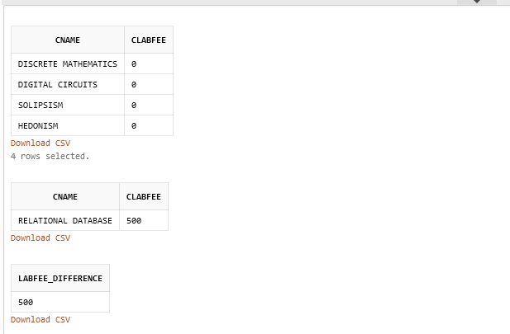

SELECT MIN(clabfee) AS min_fee,

MAX(clabfee) AS max_fee

FROM course;

SELECT max(CLABFEE) - min(clabfee) as labfee_difference

FROM COURSE;

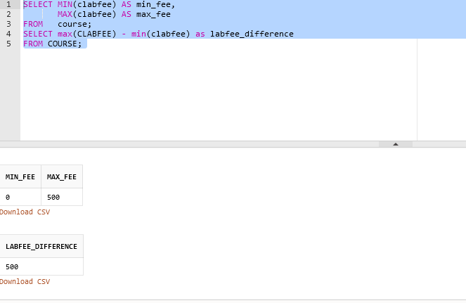

Could not figure out how to select 1 value or name of a course that did not fall in the boundaries of min or max.

What I was able to produce was

SELECT

cname,

clabfee

FROM

course

WHERE

not clabfee =(

SELECT

MIN( clabfee )

FROM

course

);

;

SELECT max(CLABFEE) - min(clabfee) as labfee_difference

FROM COURSE;

Which outputted all the courses that did not fall in the boundaries of max in min, however I was not able to just produce 1 course name, but instead all. 